

**TAYYABA REHMAN**

**BSCS 4**

**49690**

**LAB 2 TASKS**

**TASK 1:**

**BOOKS:**

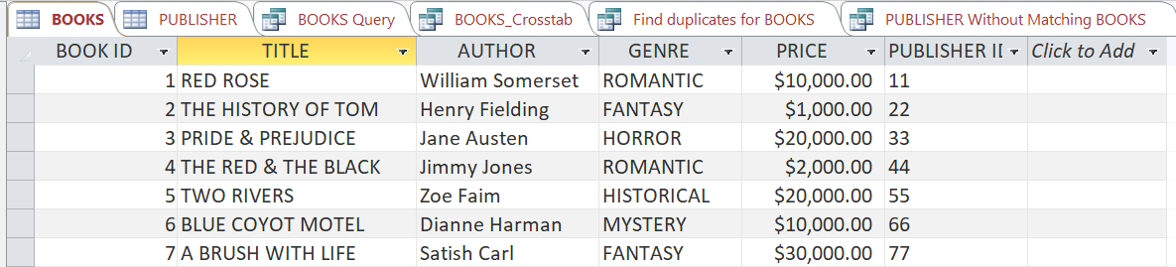

**PUBLISHERS:**

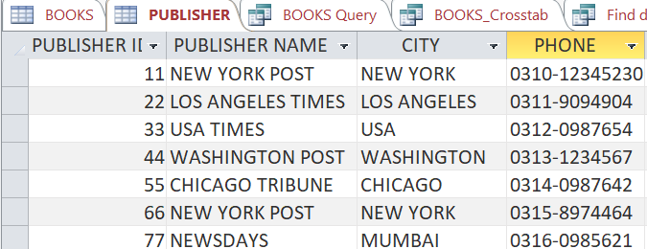

**Simple Query Wizard:**

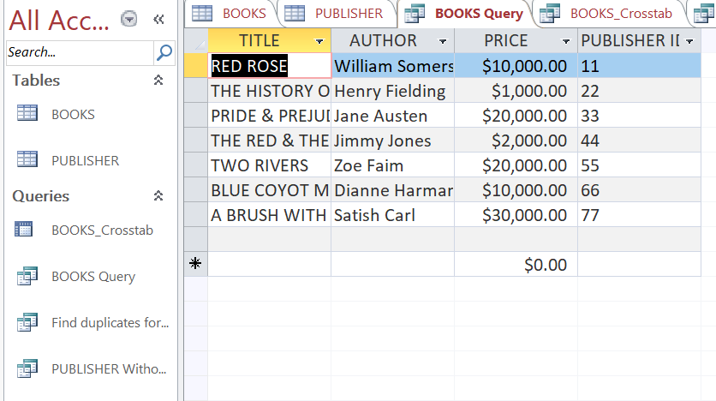

**Crosstab Query:**

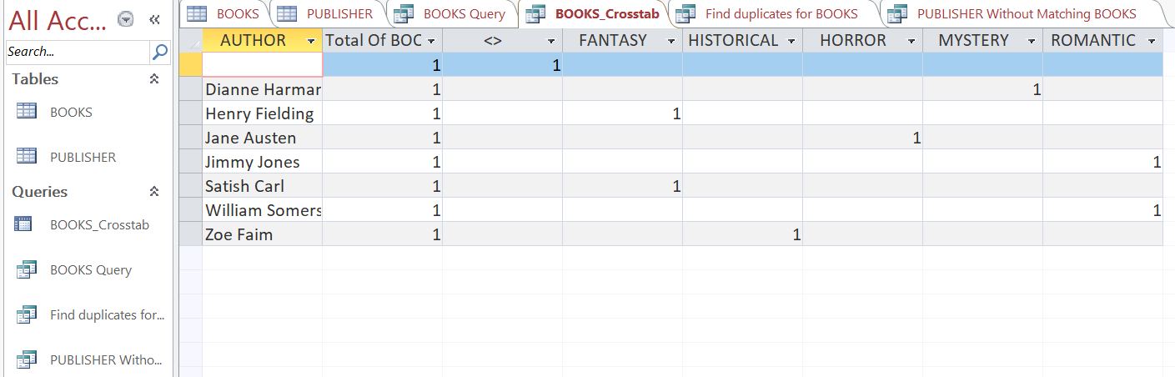

**Find Duplicates Query:**

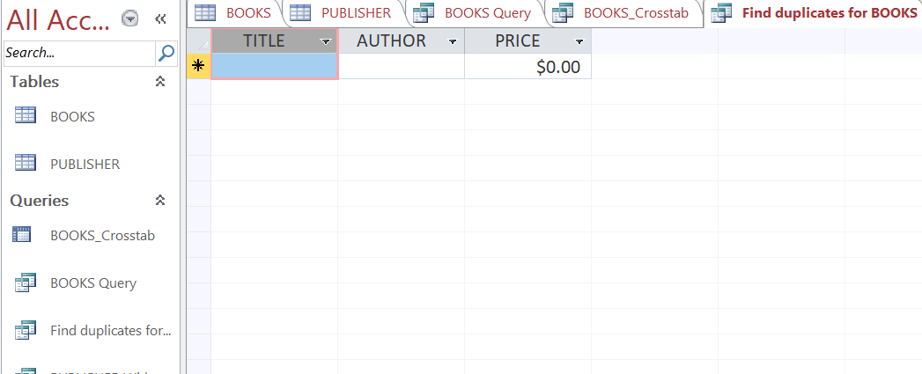

**Find Unmatched Query:**

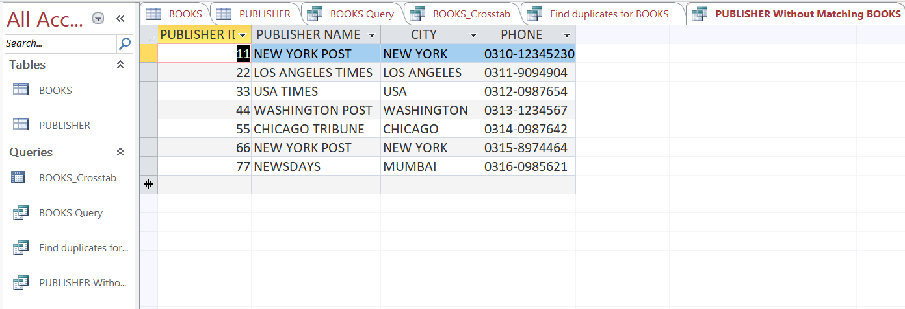

**LAB TASK 2:**

**BOOKS:**

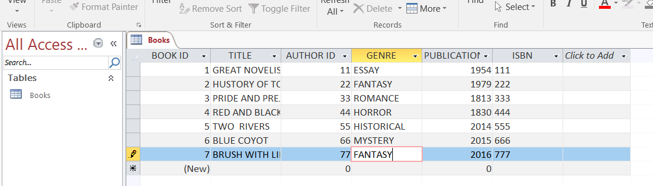

**AUTHORS:**

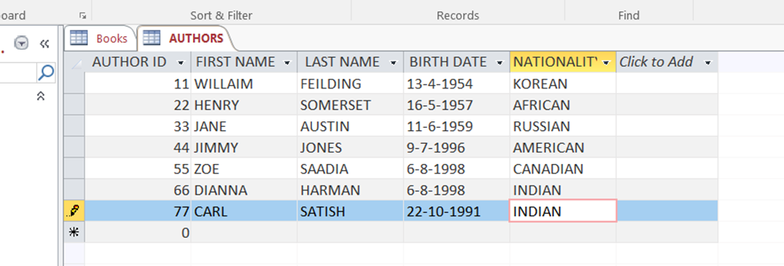

**READ:**

**LIST ALL BOOKS:**

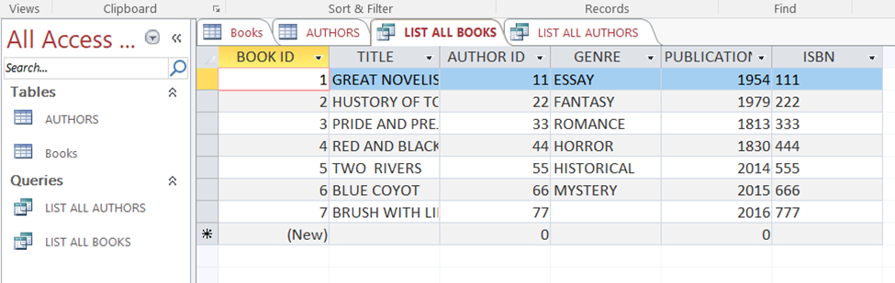

**LIST ALL AUTHORS:**

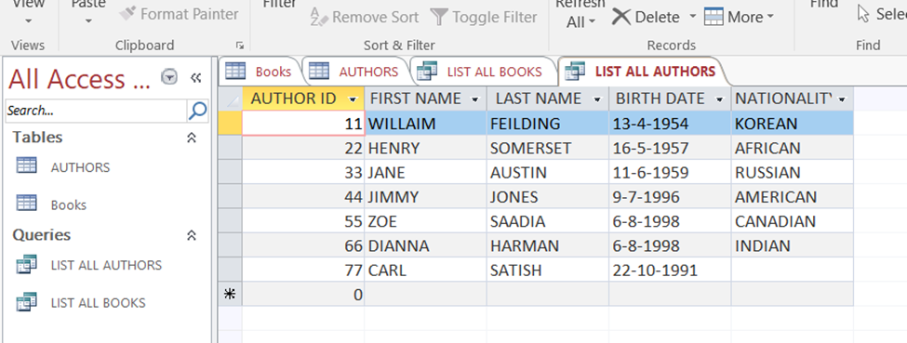

**UPDATE:**

**UPDATING BOOKS:**

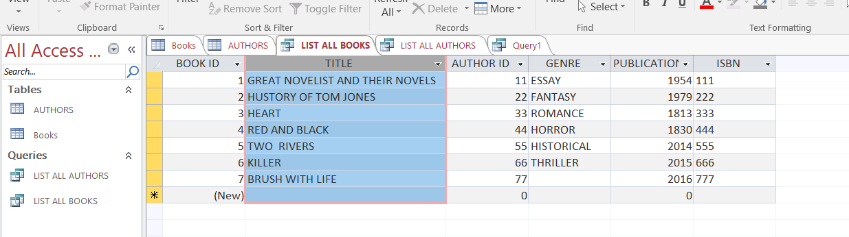

**SQL:**

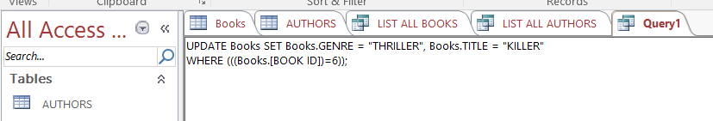

**UPDATING AUTHORS:**

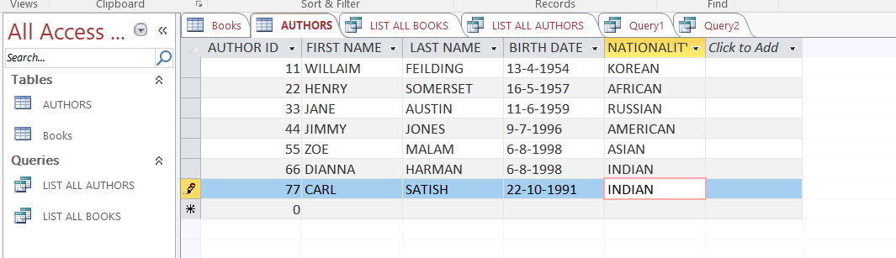

**SQL:**

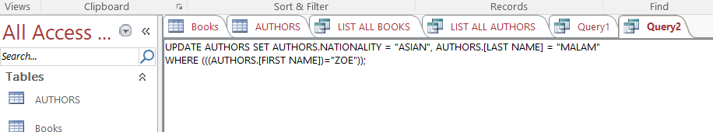

**DELETE:**

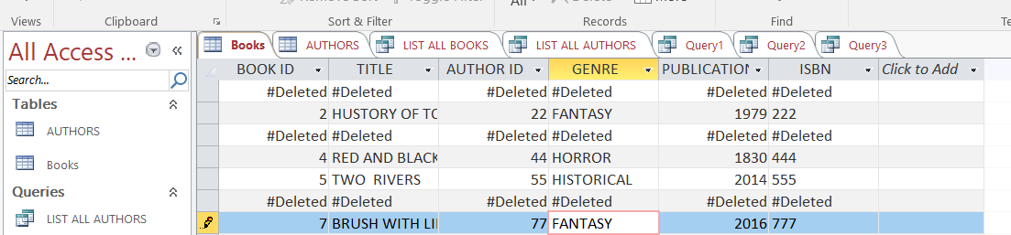

**SQL:**

